**Freelance Development Agent**

**3 PART-TIME ROLES – EAST, CENTRAL AND WEST**

**£17.85 per hour / £125 per day plus travel expenses**

**August 2020**

Are you flexible in outlook, self-motivated, passionate about seeing the South of Scotland’s tourism industry flourish and ready for an opportunity to work with local businesses and organisations to achieve more.

SSDA LTD is looking to appoint a team of 3 local development agents to support networking, business and product development across the South of Scotland. An average of 3.5 days per week is envisaged between summer 2020 and 31 March 2021 with 2-week break at Christmas/New Year. This is not likely to be fixed and could vary week on week. Payment will be based on actual days undertaken month by month.

**SSDA recently secured a £2.7m funding award from SoSE towards a 5-year work programme totalling just under £4m. This programme has 7 strands of activity.**

1. South of Scotland Covid-19 Recovery Strategy & Planning
2. Industry Leadership and Capacity Building
3. Scotland Starts Here Place Branding and On-line Package Development
4. 5-Year Destination Development Strategy Development, Monitoring & Review
5. Industry Engagement Programmes
6. Business Readiness Programmes
7. Scotland Starts Here Strategic Marketing Programme

**Central to this will be business engagement. As lockdown lifts there is a need to ensure businesses are aware of SSDA’s ambitious game plan and the support and resources available to them to support recovery and help grow their individual businesses and tourism in general in the south. A key focus is sustainable growth and responsible tourism. You will be responsible for encouraging businesses and organisations to collaborate, consider new ways of working, optimise their online visibility and bookability and develop new products responding to emerging trends.**

**To support this engagement programme, the core tasks the agents are expected to undertake include**

* *Raise awareness of SSDA Ltd and Scotland Starts Here, our ambition and how to get involved*
* *Empower and encourage collaboration between businesses within the South of Scotland*
* *Communicate regularly with local businesses and tourism groups/organisations*
* *Coordinate/facilitate local networking events, training workshops and fam trips with the Project Manager*
* *Signpost / encourage participation in available training, support*
* *Source/provide project delivery support for product and destination development activity*

You will operate as part of a team working closely with the Project Manager, Digital Community Manager, the Directors of SSDA Ltd and our core partners. You will be able to draw on a range of resources available through our partners in VisitScotland, South of Scotland Enterprise and the two Councils.

The roles will suit people with skills and experience in tourism, hospitality, community, or business development ideally in a rural area, and proven interpersonal skills for bringing people together to work on joint projects. Previous experience in partnership projects would be valuable and a sectoral interest would also be beneficial but not essential (eg wildlife, adventure, food and drink, heritage, culture).

You will be appointed on a freelance basis and be expected to use your initiative and be responsible for planning all your own work to deliver agreed outputs within agreed time allocations but working in conjunction with the Project Manager on deliverables. You will be responsible for your own tax, NI, and insurance etc. Hours of work will average 3.5 days a week and could vary from week to week/month to month depending on what is required. Delivery of tasks may involve evening and possibly weekend work to suit local business and marketing/sectoral group needs.

**The key skills and experience we are seeking include:**

* Community/business engagement
* Integrated rural development and partnership projects
* Knowledge and awareness of the tourism sector ideally from a South of Scotland perspective
* Good interpersonal skills
* Self-motivation and using your own initiative
* Good organisational skills

Invoicing will be on a monthly basis. You are expected to be geared up for freelance/home working and to have your own PC/laptop and mobile phone available for use and be able to drive with access to a vehicle and insurance for business related travel. You must have or obtain your own relevant insurances and provide proof of this before commencing.

We have loosely broken the geography of the South of Scotland into 3 zones – WEST, CENTRAL and EAST. Ideally we are seeking an agent for each area who is based within that area and has both a good understanding of the industry and local geography/activity and also has previous experience of working with businesses, groups and organisations within that area. The boundaries are not fixed and will be explored by the team once all agents are appointed.

|  |  |
| --- | --- |
| **AREA** | **GEOGRAPHIC AREAS** |
| AREA 1  West | STRANRAER & THE RHINNS OF GALLOWAY |
| WIGTOWN |
| GALLOWAY |
| SOLWAY FIRTH/COAST |
| AREA 2  Central | NITHSDALE |
| DUMFRIES |
| ANNAN AND ESKDALE |
| SELKIRKSHIRE |
| HAWICK, DENHOLM AND HERMITAGE |
| AREA 3  East | TWEEDDALE |
| GALASHIELS |
| LEADERDALE AND MELROSE |
| BERWICKSHIRE |
| KELSO, JEDBURGH AND DISTRICTS |

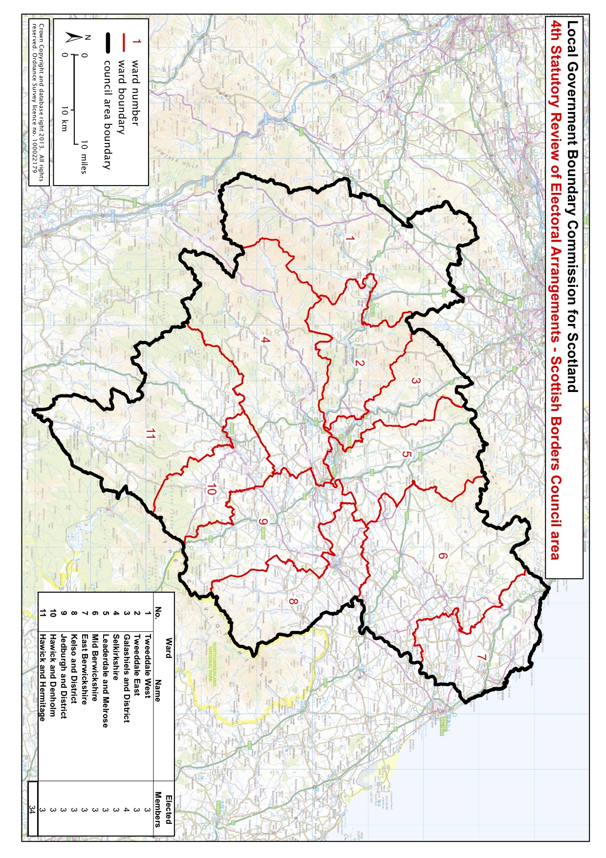

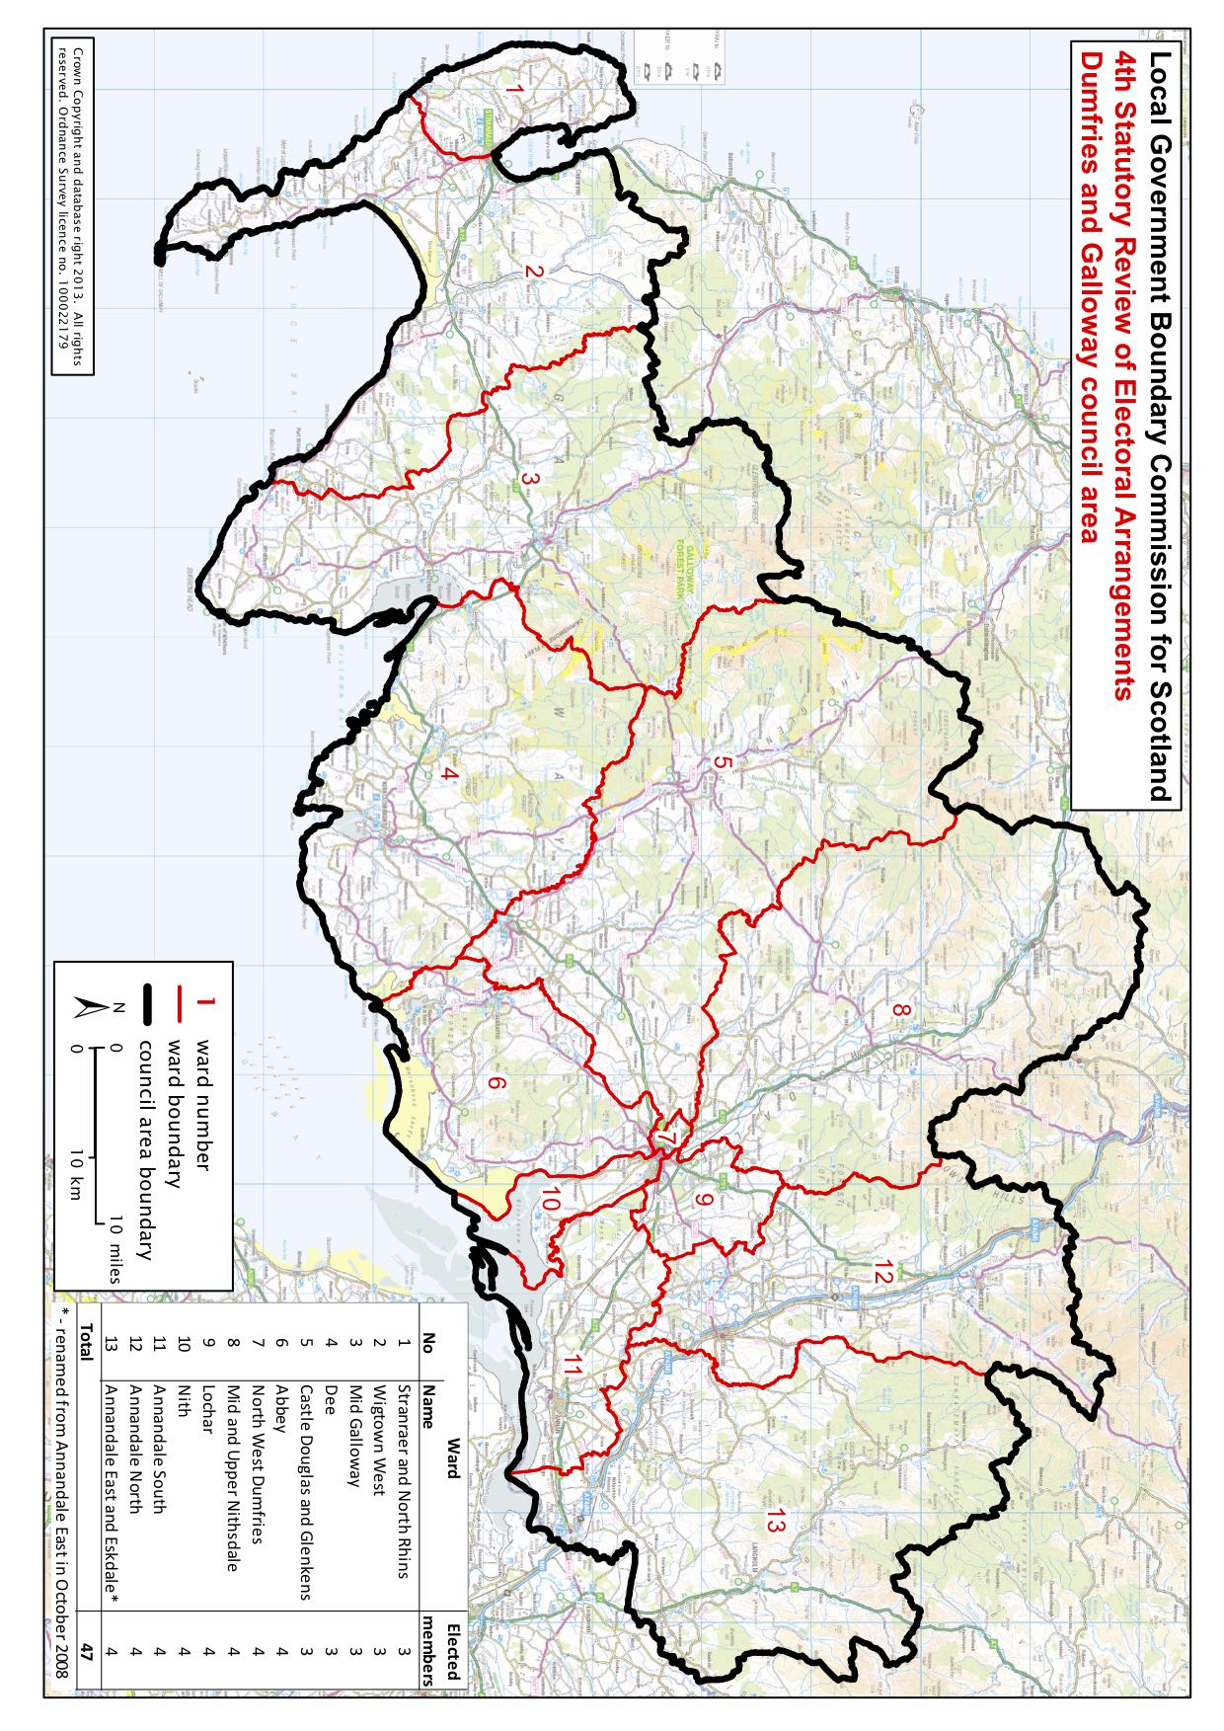

**TENDERS**

Tenders should be set out on the form provided, and must be submitted electronically to [info@SSDAlliance.com](mailto:info@SSDAlliance.com). A zoom interview is anticipated closely following the return date and this will be arranged at a mutually convenient time. Successful contractors will be advised in early course with a view to starting the contract immediately.

**Deadlines**

* Closing date for submission is Wednesday 19th August 2020 by midnight
* Successful candidates for interview will be notified by Friday 21st August at 5pm
* Interviews will take place the week off the 24th August
* Awarded candidates advised by 26th August
* Start date the week commencing 31st August 2020

**MORE ABOUT SSDA Ltd**

**To find out more about SSDA Ltd visit our website** [www.SSDAlliance.com](http://www.SSDAlliance.com)  **and if you have a specific query about these freelance agents roles please email**

[info@SSDAlliance.com](mailto:info@SSDAlliance.com)

**SOUTH OF SCOTLAND DESTINATION ALLIANCE LTD**

**DEVELOPMENT AGENT TENDER**

|  |  |  |  |  |
| --- | --- | --- | --- | --- |
| **Requirement** | | **Response – text box will expand as you type. Please note the word counts stated.** | | |
| **AREA OF SOUTH OF SCOTLAND I WOULD LIKE TO COVER (PLEASE PLACE AN ‘X’ OR SHADE THE BOX)** | | **WEST** | **CENTRAL** | **EAST** |
| **NAME** | |  | | |
| **EMAIL** | |  | | |
| **TEL NO** | |  | | |
| **ADDRESS** | |  | | |
| Summary CV (outline of career background, relevant qualifications and recent work experience) – attach full CV with form - (200 words) | |  | | |
| Please state why you are applying for this freelance position and what it is that appeals to you | |  | | |
| Outline the key strengths you offer for undertaking this role (200 words) | |  | | |
| 2-3 examples of previous work/project experience of relevance to this role. (150 words per example) | |  | | |
| Your current grasp of tourism in South of Scotland and the key challenges and opportunities you expect this role will encounter (250 words) | |  | | |
| Knowledge and understanding of your preferred geographic area (200 words) | |  | | |
| Please state any sectoral interests and outline your experience in this sector (wildlife, adventure, food & drink, events & festivals, culture & heritage) and your involvement in that sector(s) | |  | | |
| Current time commitments – please advise on any other time commitments and likely availability in days per week for this contract | |  | | |
| Confirmation you have access to a car, have a full driving licence and are insured to use it for work purposes. | |  | | |
| Confirmation you will obtain / provide your insurance documents should you be successful for the role. | |  | | |
| Confirmation you are geared up for freelance/homeworking and have a pc/laptop and mobile phone and appropriate office equipment for use on this freelance contract. Please state where you will be based. | |  | | |
| **Referees – please give details of 2 people who know you well in a work capacity and are familiar with your specific skills for this type of role. Under ‘relationship’ please state how you know the individual.** | | | | |
| **Referee 1** |  | | | |
| Name |  | | | |
| Relationship |  | | | |
| Email |  | | | |
| Tel no. |  | | | |
| **Referee 2** |  | | | |
| Name |  | | | |
| Relationship |  | | | |
| Email |  | | | |
| Tel no. |  | | | |

**Terms and Conditions of Tender**

**I wish to apply for the freelance position of Development Agent with SSDA Ltd at an hourly rate of £17.85 /daily rate of £125.**

**I confirm I am up to date with all my tax, NI and other liabilities and understand it is my responsibility to organise payment of tax, NI and other liabilities associated with this freelance position.**

**I understand I will be required to keep a record of my activity as a development agent and expenses incurred, and that I will receive payment for time incurred based on submission of an invoice to SSDA Ltd at the end of each month. I also understand that there is a fixed budget available for time incurred on agreed activity and I will manage my time accordingly.**

**I understand this contract is freelance and flexible to meet the needs of SSDA Ltd, and therefore not regular hours. I also understand that it can be terminated with one month’s notice by either party (or such other period as is mutually agreed).**

**I confirm I have the capacity to undertake this freelance role and that I am generally available. Where this is not the case, I have noted below any specific restrictions I have on my time availability.**

**Signature .......................................................................................................**

**Name ..............................................................................................................**

**Date ................................................................................................................**

**My time restrictions/other commitments**

**………………………………………………………………………………………………………………………**